CS411 Homework 1

(4)
(i) w = 01#1
q₁01#1 → xq₂1#1 → x1q₂#1 → x1#q₄1 → x1#q_{reject}1

(ii) w = #!#
q₂#!# → !q₄!# → !!q₅# → !q₁!# → q_{accept}!##

(5)
A = {e, 11010, 1101011010, 110101101011010, . . .}

Let M be the Turing machine(Q, Σ = {0, 1}, Γ = {0, 1, x, |_|}, δ, q₁, q_{accept}, q_{reject}.}) where Q =
Q = {q₁, q₂, q₃, q₄, q₅, q_{accept}, q_{reject}} and

δ(q₁, 1) = (q₂, R) δ(q₁, |_|) = (q_{accept}, L) δ(q₁, 0) = (q_{reject}, L)
δ(q₂, 1) = (q₃, R) δ(q₂ |_|) = (q_{reject}, L) δ(q₂, 0) = (q_{reject}, L)
δ(q₃, 1) = (q_{reject}, R) δ(q₃, |_|) = (q_{reject}, L) δ(q₃, 0) = (q₄, R)
δ(q₄, 1) = (q₅, x, R) δ(q₄, |_|) = (q_{reject}, L) δ(q₄, 0) = (q_{reject}, L)
δ(q₅, 1) = (q_{reject}, L) δ(q₅, |_|) = (q_{reject}, L) δ(q₅ 0) = (q₁, R)

Final states:
q_{accept} = decide w ∈ A
q_{reject} = decide w not ∈ A

(6)
Let M₁ be the Turing machine (Q, Σ = {1, 2, 3, 4}, Γ = {1, 2, 3, 4, |_|}, δ, q₀, q_{accept}, q_{reject}.}) where Q = {q₀, q_{accept}, q_{reject}} and

δ(q₀, 1) = (q₀, R) δ(q₀, 2) = (q₀, 4, R) δ(q₀, 3) = (q₀, R) δ(q₀, 4) = (q₀, 2, R)
δ(q₀, |_|) = (q_{accept}, R)

(7)
(i) concatenation (◦)

Proof:
Let L₁, L₂ = Turin-recognizable language
Let M₁, M₂ = TMs recognizing L₁, L₂
Let w = input
Testing L₁ ◦ L₂ = {w₁w₂ | w₁ ε L₁ and w₂ ε L}
Let M₃ = non deterministic TM
Splitting w to w₁, w₂ non-deterministically
run M₁, M₂ on w₁, w₂ → if both accept, then accept, else reject

(ii) intersection (∩)

Proof:
Let M₁, M₂ = TMs recognizing L₁, L₂
Let w = input
Testing L₁ ∩ L₂ = {w | w ε L₁ and w ε L₂}
Let M = TM
run M₁ on w → if accept:
then run M₂ on w → if accept, then accept, else reject

Difference with concatenation is for union we can run M₁ and M₂ consecutively.

(iii) Turing-recognizable languages are not closed under complementation.

For a Turin-recognizable language L, with M deciding L. Then the turing machine for the complement is M₁ deciding on language L₁ which on input w, accepts if M rejects, and accepts otherwise. Input w belongs to either L or L₁, hence one of the TMs have to accept. This would mean that either L or L₁ is decidable, but because there are Turin- recognizable languages that are not decidable(e.g. the halting problem) this can’t be true.

(9)
• Injective Function f from {1, 4, 8, 16} to {1, 3, 5, 7, 9, 11, 13, 15}:

Set A = {1, 4, 8, 16} (Domain)
Set B = {1, 3, 5, 7, 9, 11, 13, 15} (Co-Domain)
f is one-to-one (injective) if f(a) ≠ f(b) whenever a ≠ b
every element from the domain must be mapped to an element to the co-domain
only 1 element from the domain can be mapped to the co-domain
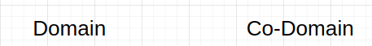

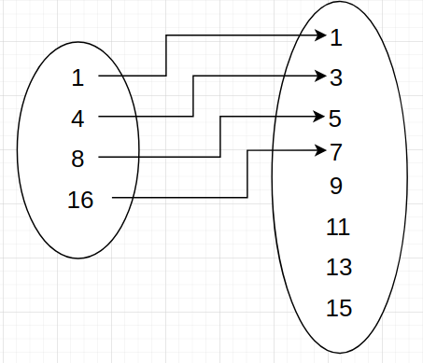

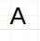

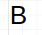

• Non-Surjective Function g from the set of all integers {. . . , −2, −1, 0, 1, 2, . . .} to the set {3, 6, 9, 12, . . .}:

Set A = {. . . , −2, −1, 0, 1, 2, . . .} (Domain)
Set B = {3, 6, 9, 12, . . .} (Co-Domain)
g is onto (surjective) if for every b in B exists a in A such that f(a) = b, which means g is non-surjective if there’s a least one b in B for which a doesn’t exist in A.
9 in B is not mapped to any a in A => g is non-surjective.
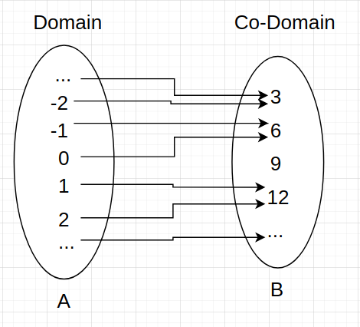

• Bijective Function h from the set of positive integers divisible by 2019 to the set of positive integers divisible by 2020:

Set A = {2019, 4038, 6057, 8076, . . .}
Set B = {2020, 4040, 6060, 8080, . . .}
h is a one-to-one correspondence (bijection) if it’s one-to-one and onto.
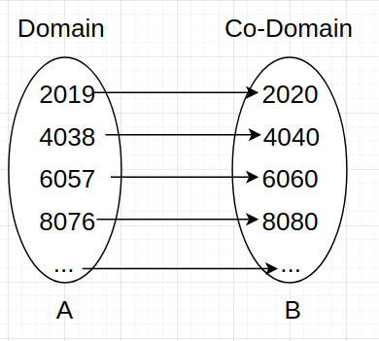

(10)

Answer:
Suppose that such a correspondence exists:
1 → X 1,1 X 1,2 X 1,3 X 1,4 X 1,5 X 1,6 ...
2 → X 2,1 X 2,2 X 2,3 X 2,4 X 2,5 X 2,6 ...
3 → X 3,1 X 3,2 X 3,3 X 3,4 X 3,5 X 3,6 ...
4 → X 4,1 X 4,2 X 4,3 X 4,4 X 4,5 X 4,6 ...
.
.
.
Construct a string b 1 b 2 b 3 b 4 ... from the alphabet {s, t} such that b i does not equal x i,i .
The string is not in the list above! This is a contradiction, meaning the set B is
uncountable.

